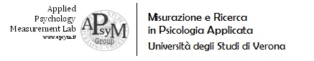


Dottorato di Scienze Umane
Università di Verona

APPLICATION FORM

Multilevel modeling:
from simple direct cross-level effects to complex moderated mediation models

ONLINE COURSE, 13 - 17 JULY 2020

NAME
SURNAME
ACCADEMIC POSITION
- PhD student, first year
- PhD student, second year
- PhD student, third year
- Post doc or research fellow
- Assistant professor (temporary)
- Faculty member (permanent assistant professor / professor)

UNIVERSITY (DEPARTMENT)

RESEARCH TOPIC (MAX 3)

1) Which statistical techniques for multilevel data do you know? (max 5)
1.
2.
3.
4.
5.

2) Which statistical techniques have you used on your researches? (max 5)
1.
2.
3.
4.
5.

3) Which statistical techniques you'd like to learn and apply for your researches? (max 5)
1.
2.
3.
4.
5.

4) Have you already analysed multilevel data?

Yes No

5) Which kind of data do you use and analyse?
Studies with multiple levels (e.g. individual, group, organization)
Experience sampling studies
Diary studies
Other: .......................................................................................................................

6) Please evaluate your knowledge about each following statistical software:

Mplus
1 very low 2 low 3 sufficient 4 medium 5 high 6 very high

SPSS
1 very low 2 low 3 sufficient 4 medium 5 high 6 very high

